Trinity Church
Located in Historic Downtown Petersburg, Virginia
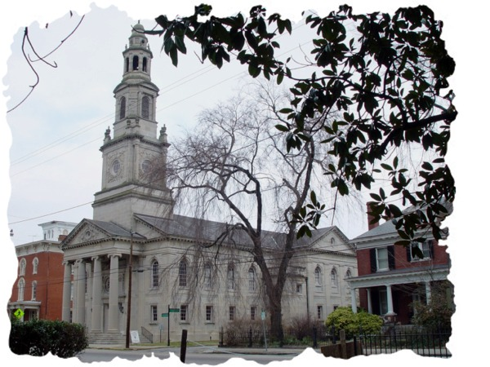
Rich in tradition, surrounded in history, yet focused on the future,
Trinity United Methodist Church continues weekly services today
much like it was done on June 8, 1857.

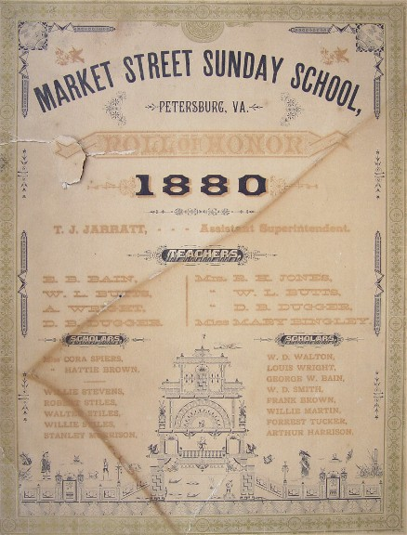

Organized as Market Street Methodist Episcopal Church South
on June 8, 1857,The first building was constructed on Market
Street at Halifax at a cost $24,000.00.

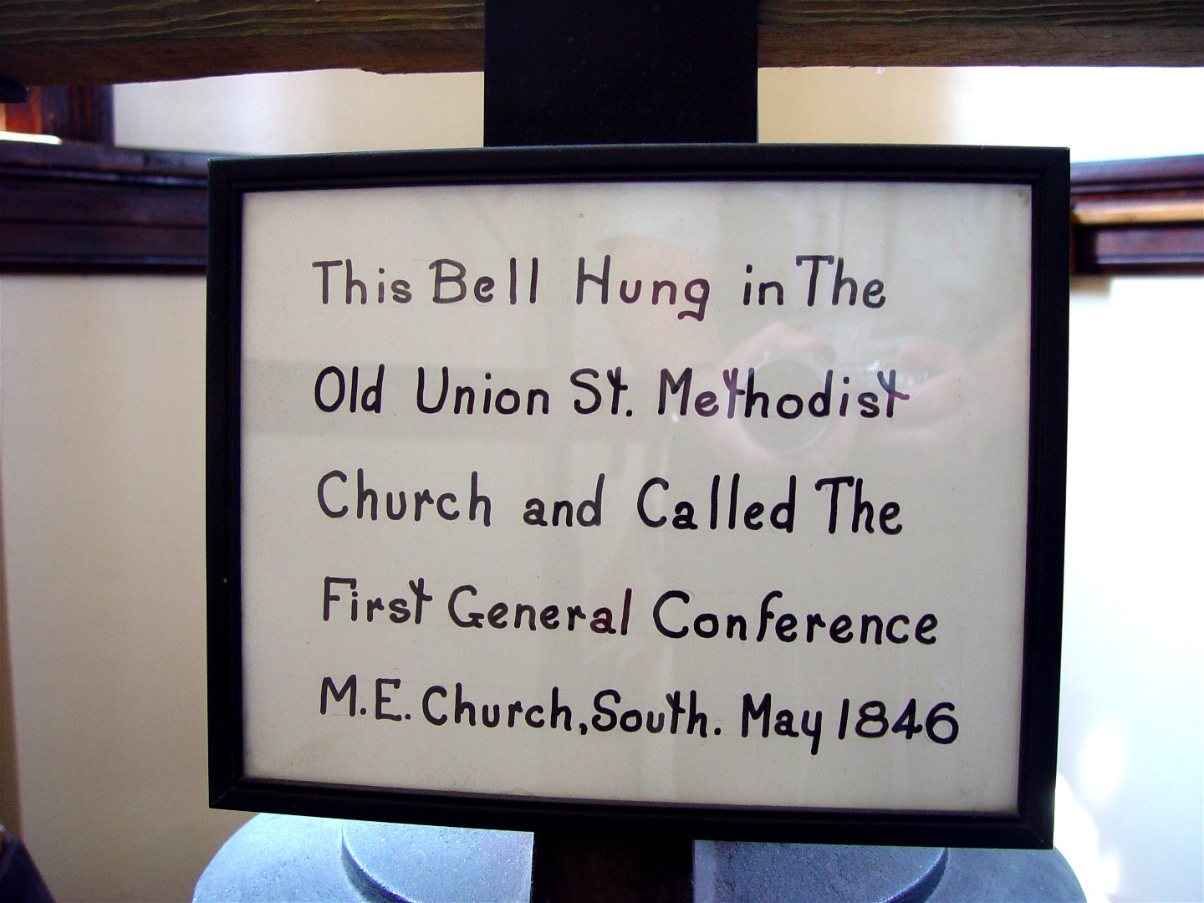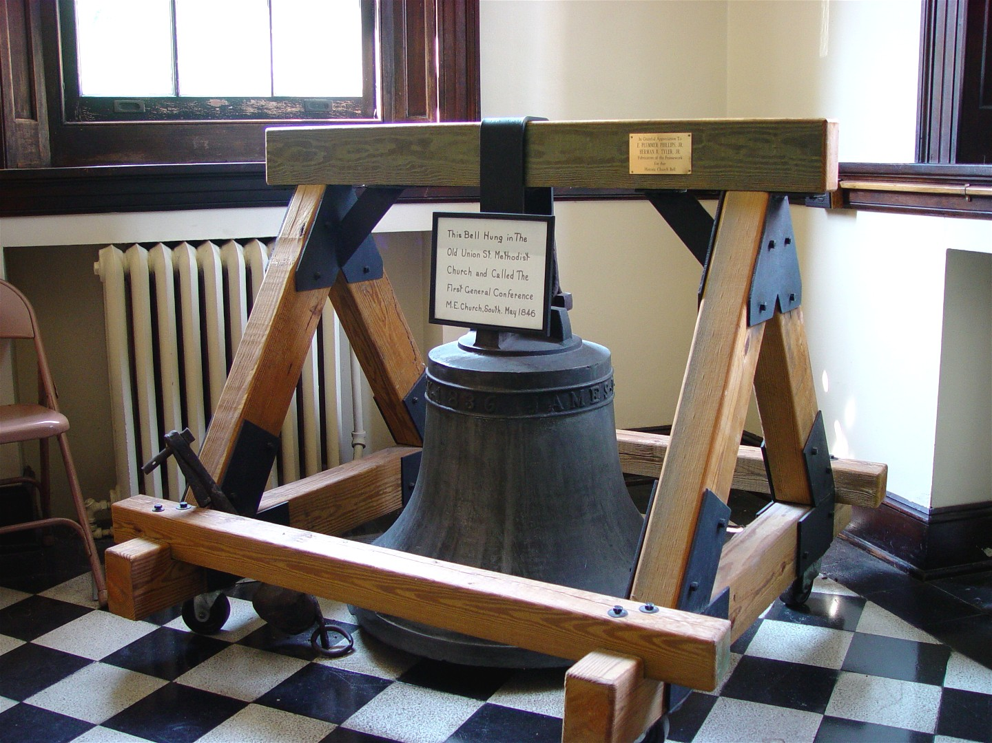
Trinity Church moved to the current building on South
Sycamore Street on February 25, 1923. Trinity Church was
designed by architect R.E. Mitchell and was constructed of
Indiana limestone. The Georgian revival structure was
inspired by St. Martin in the Field Chapel near London, England.

The inside sanctuary acoustics is considered one of the best
anywhere, making it ideal for musical programs.

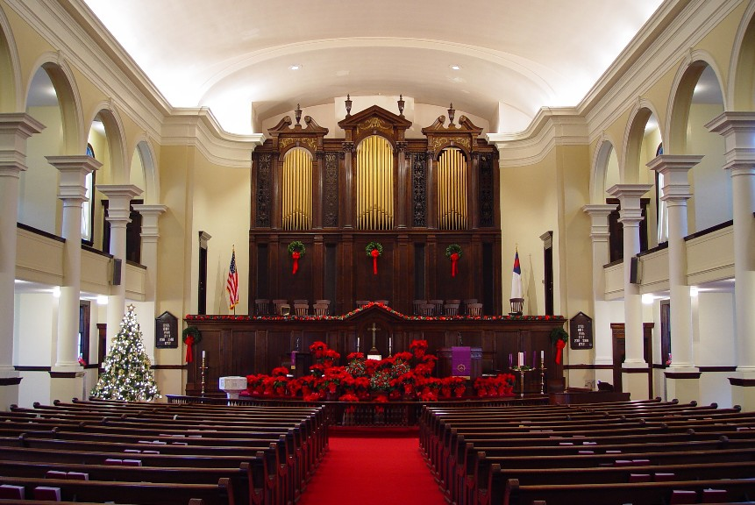
Trinity holds quarterly concerts open to the public free
of admission. While we have regular groups participate,
we are always open for new musical programs.

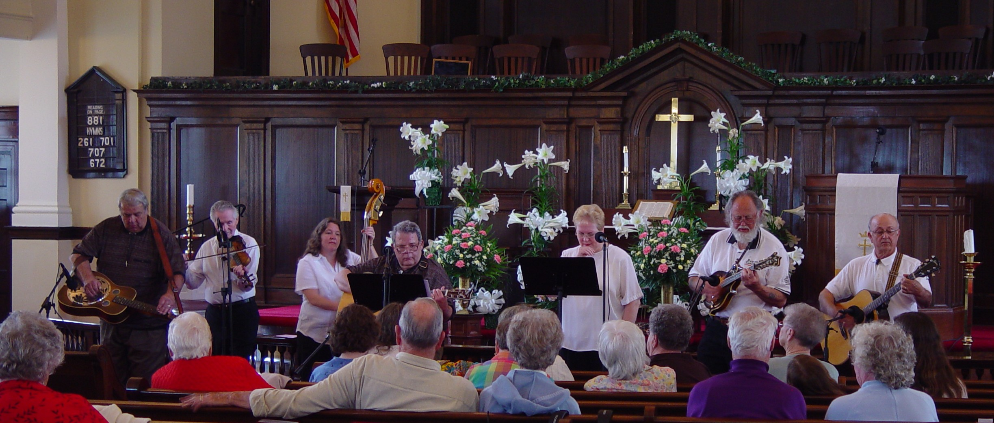
Whirley Brothers Bluegrass Gospel Group
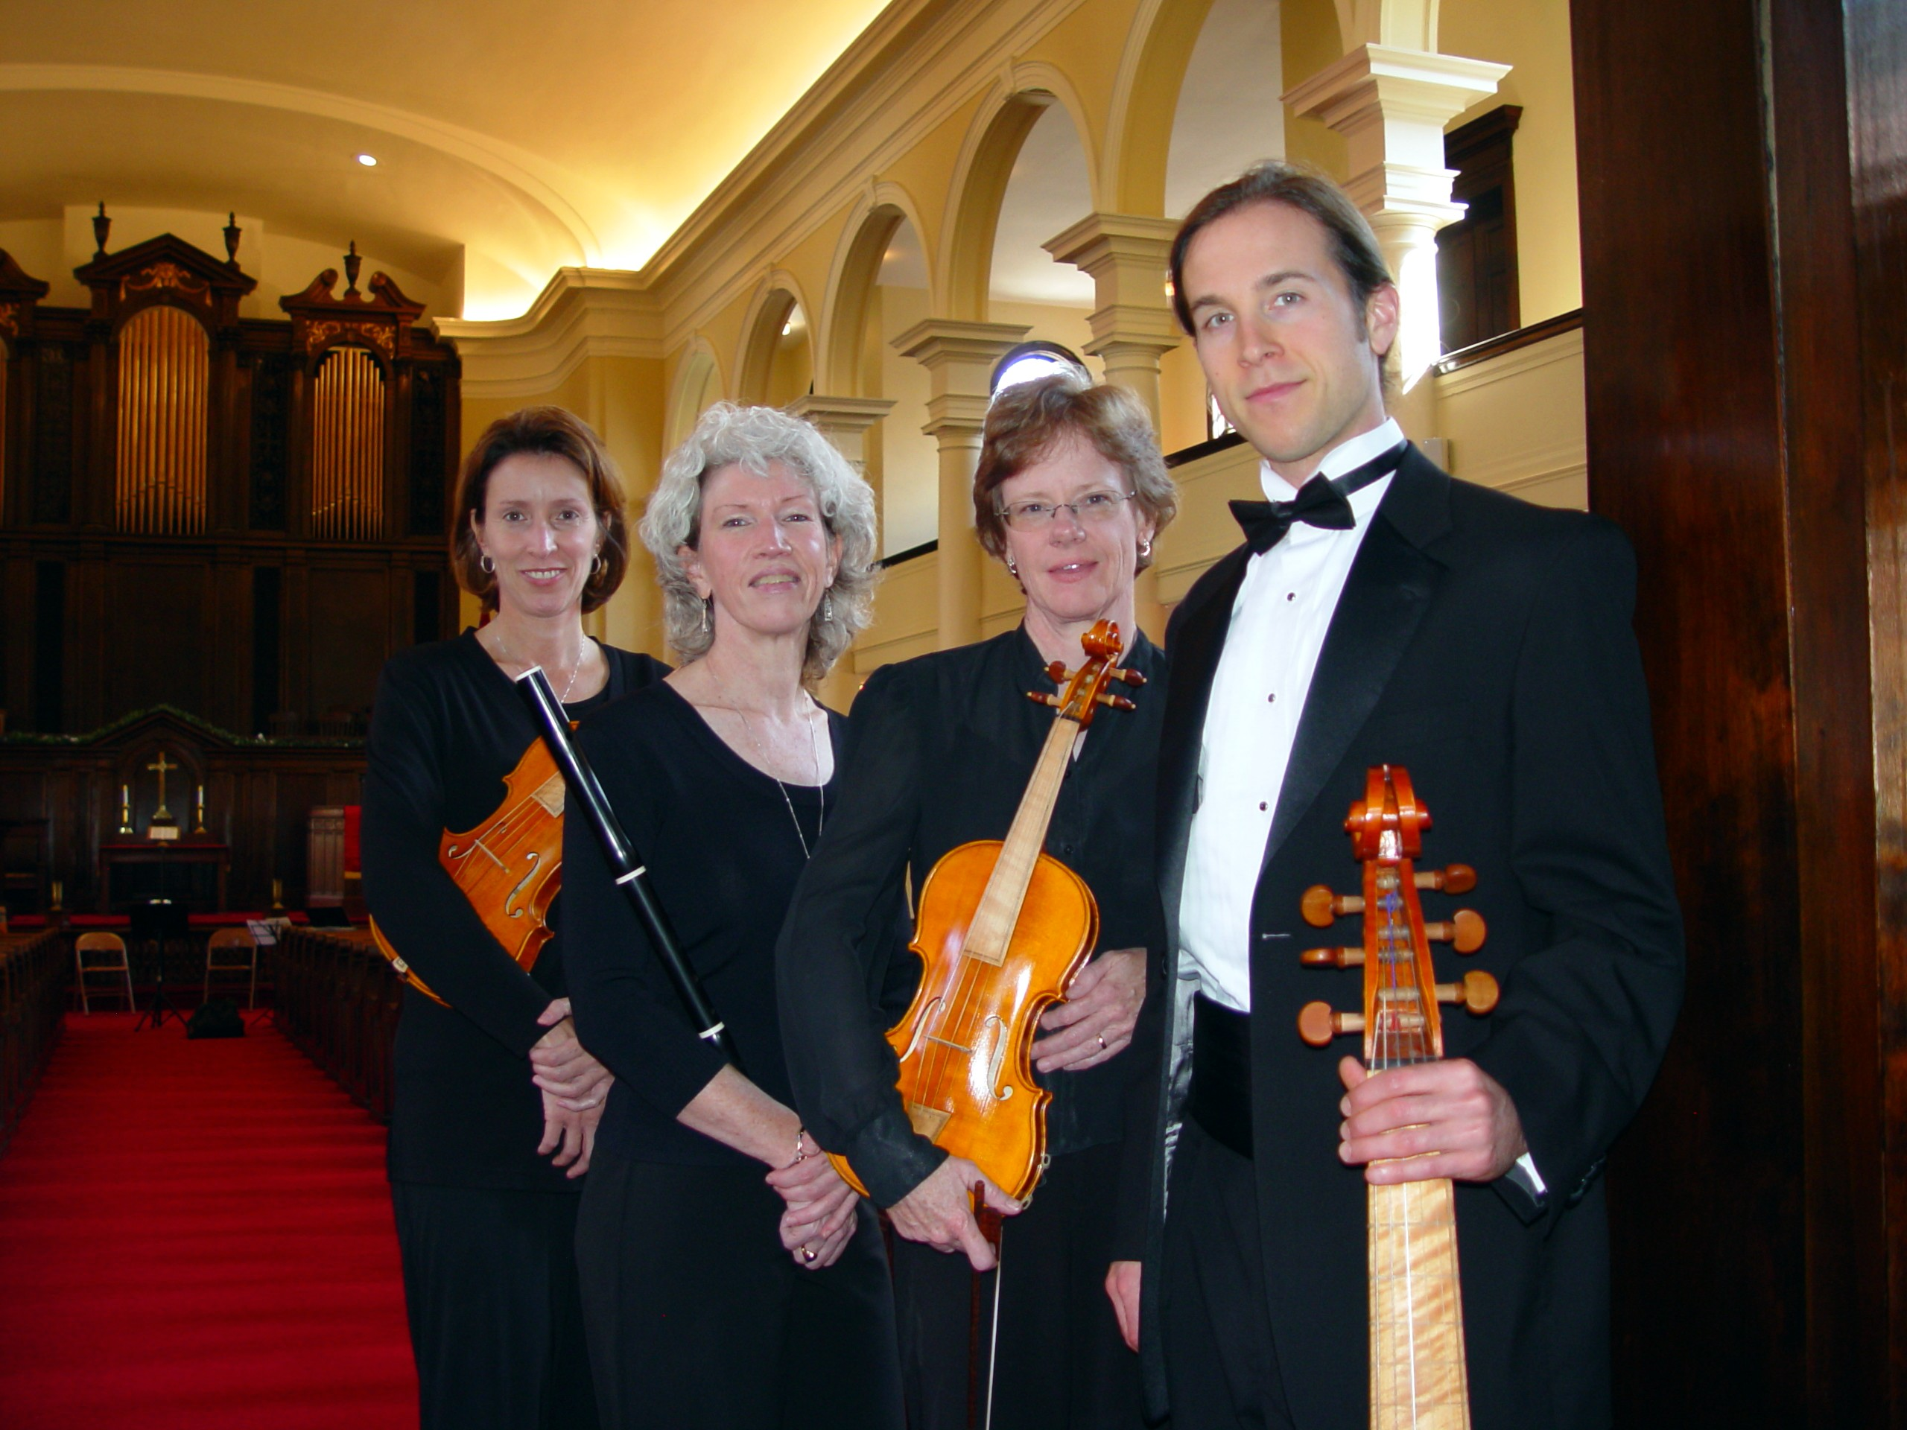
The Appomattox Chamber Society
(ACS) focuses on the performance of Baroque and early
Classical Chamber music on period instruments.

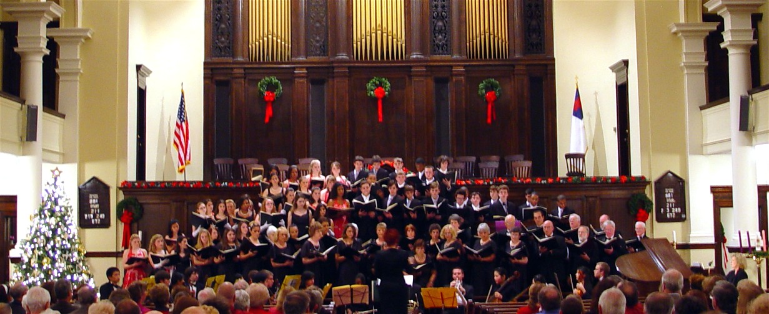
Petersburg Festival Chorus
Directed by Sandra Thomas, a diversified group of singers
performing a variety of selections.

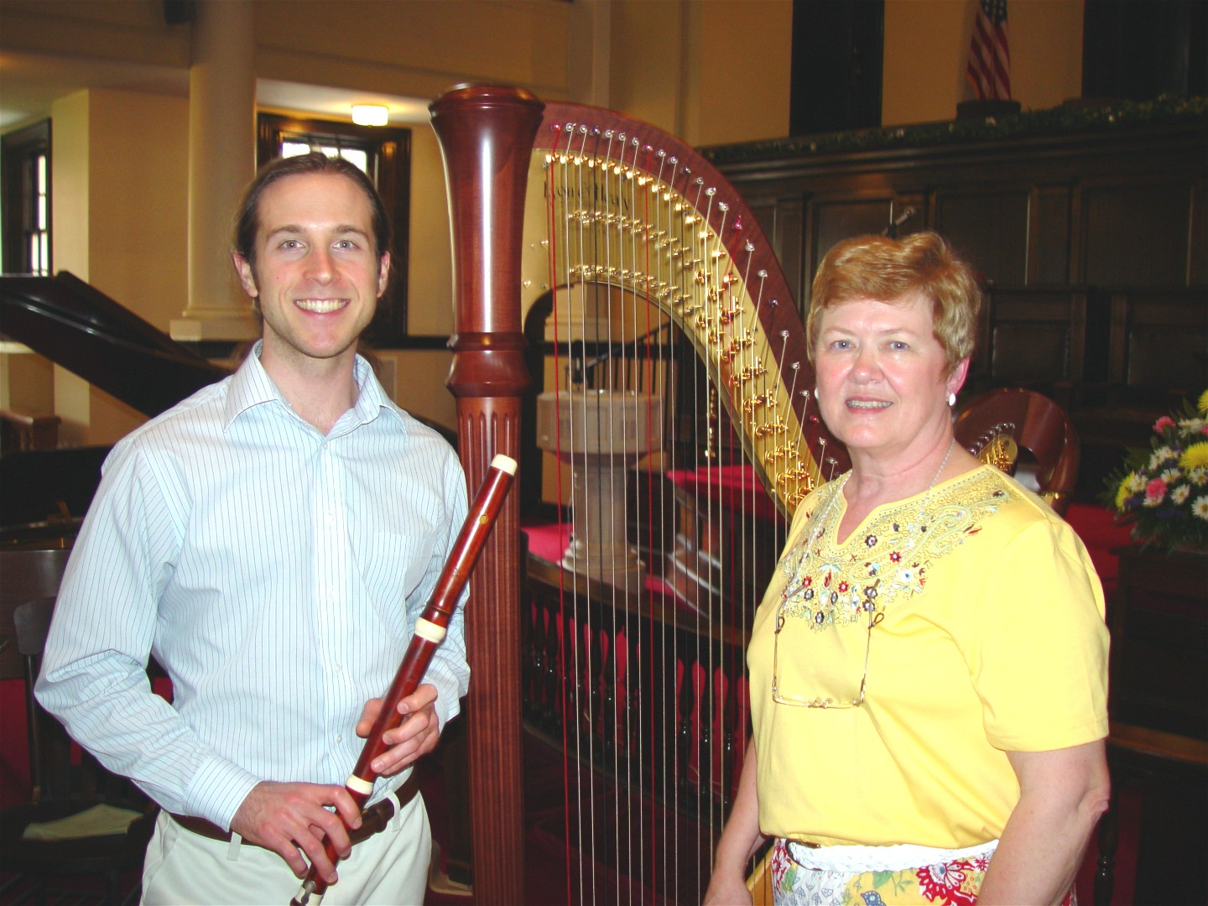
Louise Jefferson Daniel on Organ, Harp, and Piano with Jonathan Shockley
on Flute.

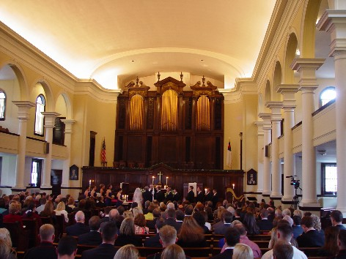
Trinity offers our facilities for special events. Contact our
church office for details.

We at Trinity invite you to visit with us at any of our
services or upcoming special events.

Schedule of Services
Good Morning Fellowship each Sunday Morning at 10:00 a.m.
A time to fellowship while enjoying a light beverage or snack.
Come when you can and leave when you must, open door policy.
Open to all ages, share a testimony or favorite verse, and enjoy
a short Bible message for today's challenges. Bring a friend.
Sunday Morning Worship is at 11:00 a.m.
Minister: Rev. Dr. Gerald Miller
Everyone Invited.
Wednesday Morning Bible Study is at 10:00 a.m.
Gather at 10:00 a.m. for coffee and fellowship.
Class begins at 10:15 a.m.
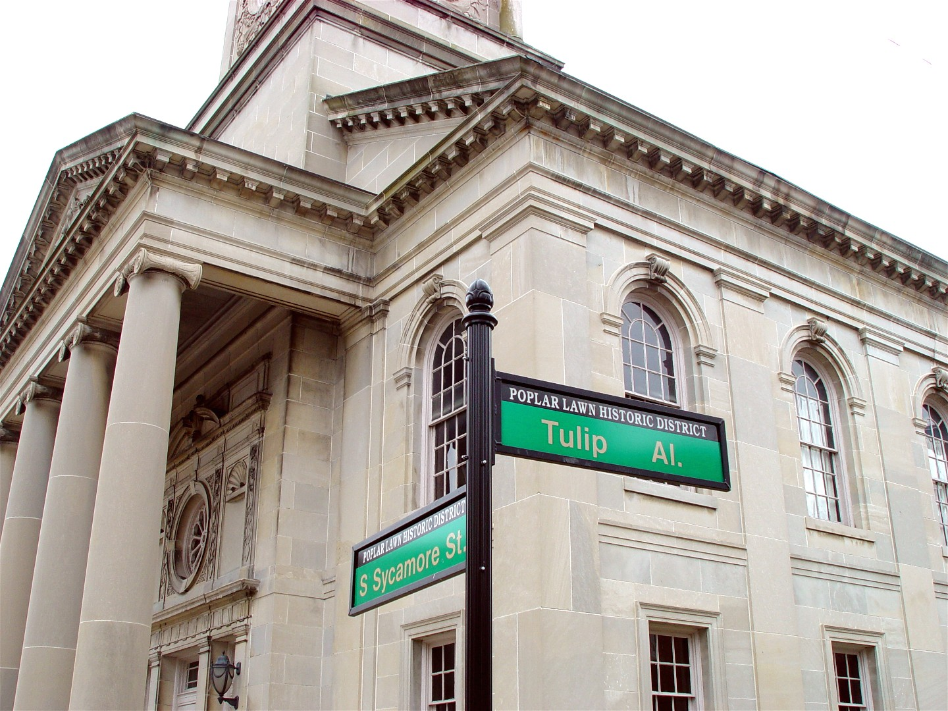
Trinity United Methodist Church
215 South Sycamore Street Petersburg, Virginia 23803
(804-732-3216) www.wcast.info/trinity trinity@wcast.info
"Your Neighborhood Church"

